Exercise 3

- List all employees whose last names begin with P.
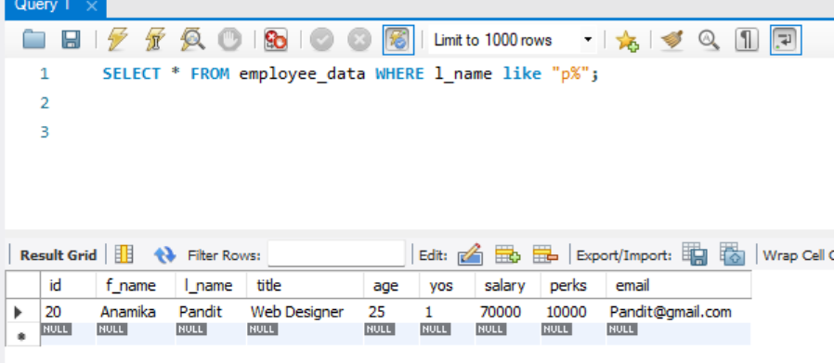
- Display the names of all employees in the marketing division
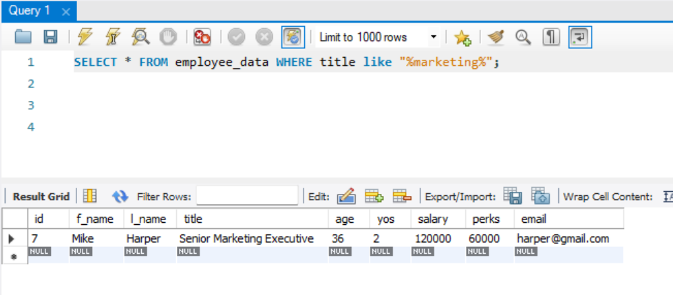
- What will the following statement display
SELECT f_name, l_name, Salary from employee_data where f_name like ‘%k%’;

Returns first name, last name and salary of all employee that has at least one k on their first name

- List the last names and titles of all programmers
